IMPLEMENTATION OF THE SMART PARKING SYSTEM IN THE CITY OF BELGRADE AS PART OF SMART-CITY SUBSYSTEM
Dragan ZlatkovicVladimir MikicNebojsa DenicMilos Ilic

Abstract: Parking and traffic jams are constant sources of frustration for all road users in most cities around the world. It is therefore not surprising that smart parking services are among the first requirements of local governments when it comes to equipping smart cities. Since parking is a critical point of cities, especially large ones, there is a need to introduce technological solutions that would make it easier for citizens and tourists to find parking, pay, inform about the number of free parking spaces, etc. Also, in terms of parking management, special parking zones, traffic jams caused by the search for parking and systematic management of all of the above, cities are looking for modern software solutions. It is estimated that about 40% of urban traffic is caused by drivers looking for parking spaces.
Key words: smart cities, smart parking solutions, urban traffic, parkinng managment.

INTRODUCTION
Smart cities bring together infrastructure and technology to improve the quality of life of citizens and boost their interactions with the urban environment. So, the city of the future will be smart. It is entirely interconnected with traffic regulation and smart parking, saves energy, has free city-wide Wi-Fi and fights crime, assisted by Big Data and the Internet of Things (IoT) [1] – [3]. Smart parking is a system that offers drivers information on how many empty parking spaces there are on nearby parking lots and other appropriate information such as zone, price and locality.

The Smart Parking Solutions in Serbia has been implemented in several cities.Following the example of European capitals, the system of parking sensors, which provides information on free parking slots in the streets or public garages covered by them, is already functioning in Belgrade.

“SMART PARKING” – PARKING MANAGMENT

“Smart parking” is a parking management system for outdoor and indoor parking spaces. Provides insight into the number of occupied and vacant parking slots. It works on the principle of detection of motor vehicles via sensors for measuring changes in the Earth's magnetic field, caused by the arrival of cars near the sensor in real-time. Sensors can be inserted into the ground and utilize radar or magnetometers to detect vehicles while overhead cameras installed on the light poles and rely on computer vision software for vehicle detection and pinpoint open spaces. Vans and trucks can be equipped with mobile parking detectors. The data collected from these systems can be analysed to produce useful statistics, forecasts and insights that will be valuable to local authorities when it comes to policymaking [3] – [7].
“Smart parking” solution as a service consists of three main parts [5]:
- Software as a Service (SaaS) – In this case, the telecom operator offers the software management service required for the “Smart parking” service. The data is stored in a safe place, in the operator’s data centre, where it is managed by a group of experts who also have the role of support in case of any difficulties;
- Parking management interface – Cities get a local web user portal, which is an interface through which they manage the “Smart parking” solution, and they do not need any local data centres or servers;
- Application for end-users – “Smart parking” application, based on location, used by drivers to search for parking and pay for parking services, and through which simple mobile payment is enabled.
The benefits that cities achieve by introducing a smart parking management service are multiple [6]:
- Reduction of traffic congestion related to parking by 50% due to better information on the availability of parking spaces (research shows that drivers spend 106 days looking for a free parking space);
- Increasing efficiency because the data on the occupancy of parking spaces can be used to direct drivers to free spaces;
- Reduction of traffic-related pollution in a way that avoids the long-term search for free parking spaces (any search for a parking space pollutes the environment with 1.3 kg of CO₂ emissions);
- Management of all data related to parking within one application;
- Management of approvals and access to special parking zones;
- Better statistical data as a basis for improving city policies related to parking;
- Easy integration of the service into the existing IT infrastructure of cities;
- Low maintenance costs;
- Enabling new business models in the form of advertising, special parking permits for tourists, etc.

IMPLEMENTED SMART PARKING SYSTEM IN THE CITY OF BELGRADE
The Smart Parking System (SPS) implemented in the city of Belgrade is a full Smart-City Subsystem solution (Figure 1) that was settled and fixed in production in 2016 by the Public Utility Company “Parking Service” – PUC (Serb. JKP “Parking servis”). Since the start of the development, the aim was to make it easily replicable and installable at any location in the city. It is a wholly scalable solution because of the cloud-based implementation, which permits the system to be implemented in the same way, regardless if it is covering only a few parking spaces, a small parking lot or multiple complex parking lots in a large city. The development of the solution towards the above-mentioned goal was in multiple iterations, reducing the technical hurdles and increasing overall functionalities of the system. This solution includes both software and hardware development, so it focused on fast prototyping concerning the software as well as a significant amount of time invested in hardware research, which was the most important for making this system easily replicable and installable.
Parts of the SPS solution that are reviewed [8], [9]:
- Software – Web and mobile application; and
- Hardware – Sensor nodes and routers.

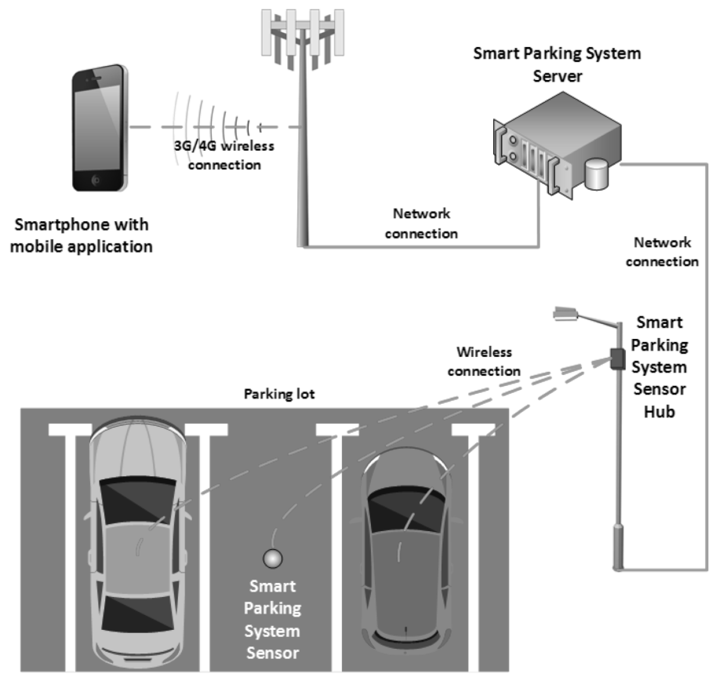
Figure 1– SPS overview
In one of the busiest parts of the city, in the area of the city municipalities of Vrachar and Savski venac (Figure 2), 3,600 sensors and about 130 info-boards have been installed, which provide information on free parking lots in real-time. This system has contributed to shortening the minutes spent in demand for parking, reducing traffic jams and exhaust emissions by 30 percent, which contributes to a healthier environment in the Serbian capital.
A large number of parking payment stations have been installed in garages and parking lots so that the billing system has been modernized and automated. Users now have the option of paying for parking without going to the cash register and contacting the collectors.
At more than 70 locations, about 190 signs have been placed on the entrances to parking facilities. The information is updated in 60 seconds, and users can also see it on the “Parking service” website. This system shortens the time of searching for a vacant parking slots.
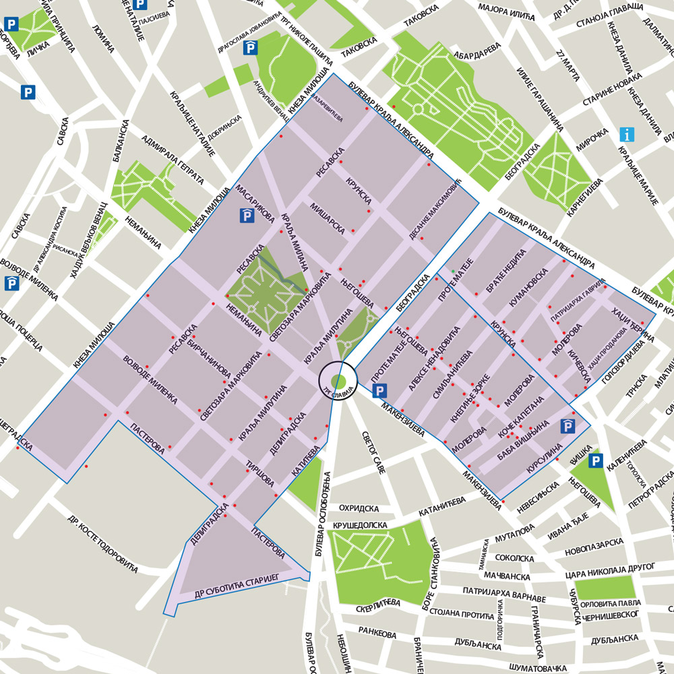
Figure 2 – Pilot parking areas in Belgrade city centre equipped with sensors

PUC “Parking Service” software
In addition to the widely available user interface, there is also the administrator’s web-based dashboard that is only accessible to city officials and administrators. The main reason why this part is not publicly accessible is that it is used for general monitoring of the SPS and its modules, specifically routers and sensor nodes [9] – [11]. The dashboard also provides important functionalities to control the SPS such as remotely restarting or enabling and disabling sensor nodes.
Mobile smartphone applications are available for both Android and iOS platforms (Figures 3 and 4), and can be used by anyone to check the current state of parking in the city of Belgrade. In addition to showing end-users information about parking lots and parking space vacancy using interactive city maps, they also provide additional features such as navigation and the possibility of paying for the parking in-app. In the background, applications gather usage data used for analytics and improvements of the already existing services.

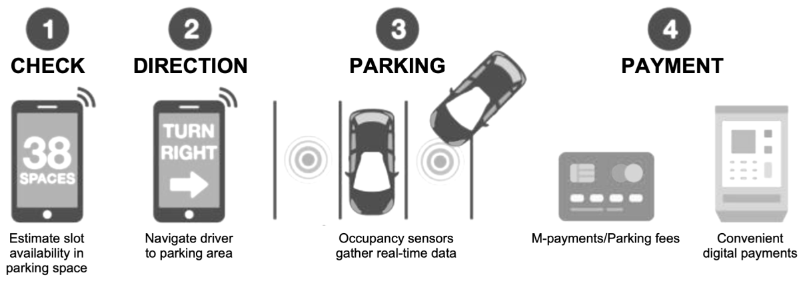
Figure 3 – Basic functionalities of the SPS

Besides finding vacant parking slots, users will also be able to pay for the parking service via the application, in three ways: by SMS, payment cards, as well as funds deposited on the application itself. At the same time, the application provides the possibility to pay the bill for the use of garages and parking lots without contact trough M-payments or by convenient digital payment such as Wallet application - Apple Pay (Figure 3).
Advanced functionalities include checking the type of parking space (residential, disabled, taxi, or delivery), penalizing improper parking, and managing access to certain parking zones.

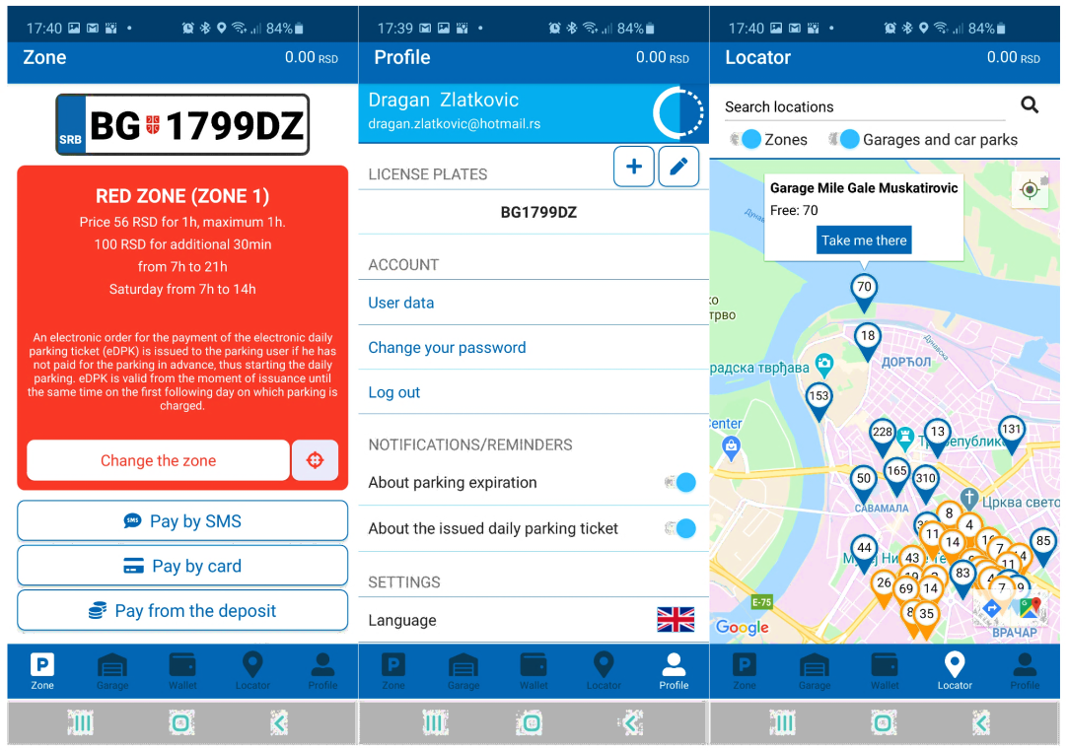
Figure 4 – “Smart Parking” application user interface of the PUC “Parking Service”

PUC “Parking Service” hardware

Sensor nodes, as a part of this solution, are composed of battery-powered wireless sensors that use infrared technology to deduce whether a parking spot is vacant. The decision to use this technology was made because it allows sensors to be easily placed on each parking spot in any type of parking lot. This solution uses wireless sensors that are battery-powered with a battery life expectancy estimated to three or more years. This is an advantage comparing to other solutions because installation of sensor nodes is simple and fast, instead of having extensive construction work to install power and communication lines for every smart parking system sensor node to work properly [11].
The sensor node is a hardware device whose main task is to detect whether the current parking spot is vacant or not and to provide the Smart Parking System with that information in real-time. The most important task of the sensor node is to send this information to the router as fast as possible over HTTP protocol using MQTT transfer protocol, thus exploiting advantages that those protocols offer in terms of instantaneous and reliable messaging capabilities [8], [11].
Aside from the main task of vehicle detection and data transfer, sensor nodes have other features including [11]:
- Network reconfiguration in the case of a router failure;
- Automatic registration and network configuration of newly added sensors;
- Error state and malfunction reports sent through using already existing channels for simplified maintenance and diagnostics.
The router component of the Smart Parking System solution is needed for transferring data to the server using two communications, the first to get information on parking spot vacancy from sensor nodes, and the second to forward gathered data from all nodes to the server in the cloud using the wireless network [8], [9].
The server receives the complete information about the current state of all sensor nodes from routers over the network. Information is gathered for single nodes using their IDs and includes GPS location and other sensor node metadata. The server is responsible for storing information into a corresponding database, which can later be used for statistics, analytics, and other system diagnostics and overviews [9].

NEW SMART PARKING AND GREEN SOLUTIONS IN THE CITY OF BELGRADE
In 2018, the “Obilicev venac” garage has received the Parksmart certificate and has fulfilled all required criteria such as reducing operational costs, increasing energy efficiency, encouraging alternate modes of transportation, minimizing waste and energy-efficient lighting and ventilation systems. This Belgrade’s ecological garage has solar panels with the solar power station, LED lights equipped with motion sensors, electric vehicle fueling stations, bicycle parking, the waste sorted into 6 categories, placemaking zones for exhibitions and cultural purposes and free Wi-Fi. In 2019 the Garage received the first prize from the European Parking Association (EPA) for the best reconstructed parking building in Europe.
The introduction of e-parking as a Smart City Subsystem, in early August 2020, is the latest result of Belgrade authorities’ strategy to develop the “Smart City”. The new electronic parking control and charging system mean that drivers who have not paid for parking in a zoned area or have exceeded the time allowed for parking will no longer receive fines attached to the windscreen. Now the controllers issue electronic daily parking tickets (eDPK), which are published in electronic form on the site, while vehicle owners will also receive a notification about the issued eDPK at their home address.
Also, the “Park and bike” campaign is a favorite service available to Belgraders. If the user parks the vehicle in the garages “Zeleni venac”, “Masarikova” and “Sava centar”, they can borrow two bicycles for adults, or four bicycles – two for children and two for adults if they leave the car in the garage “Obilićev venac” and in the parking lots “Ada Ciganlija” and “Milan Gale Muškatirović”. In 2019, as many as 50,000 fellow citizens used this kind of opportunity from the PUC “Parking Service”.

RESEARCH RESULTS
Implemented SPS demonstrated to be suitable in the area of vehicle mobility as it helps with common issues of well-organized use of vehicle travel, full operation of parking slots and great reduction of search time for a vacant parking spot. Data collected from sensors and client applications are valuable in statistics. Mostly in terms of deducting at which time of the day parking slots are mainly full and at which time of the day users leave parking lots the most. This data can be used to foresee possible traffic jamming in neighbouring streets and track behaviour patterns. Typical parking occupancy data per hour for one day are graphically presented in Figure 5.
After undertaking a seven-day research and analysis of the data received from parking sensors at the Public garage “Baba Višnjina”, installed in a parking lot that can accommodate 351 cars, we were able to realise that on average only 7% of parking slots are vacant. The biggest number of vacant parking spots occur during the working week between 15.00-19.00 which is to be expected because of the daily work routine of the people. An interesting outcome is that a lot of users tend to leave parking at night from 22:00 to 09:00 next day. Using these simple outcomes, we can conclude that there is a lot of vehicle movement during the night on the roads close to the parking lot and that when appropriate, traffic police attendance should be increased at the time.

Figure 5 – Graphical analysis of parking occupancy data for one day per hour
(Parking lot can accommodate 351 cars)

CONCLUSION
In this study, we have presented an overview of SPS currently implemented in the city of Belgrade, as a part of the Smart-City subsystem. In the current version of the SPS solution, we were able to cover major concerns in the area of vehicle mobility in the city of Belgrade, which we hope to lead towards new advances in smart city mobility solutions implemented in Belgrade and elsewhere. Our future research and development will focus on improving existing smart parking solution and extending it with regard to how new disruptive smart, mostly IoT-based and mobile, technologies will influence vehicle mobility and parking solutions in the urban area.

REFERENCES
- Gassmann, O., Böhm, J., & Palmié, M. (2019).Smart Cities: Introducing Digital Innovation to Cities. Bingley: Emerald Publishing Limited.
- Allwinkle, S., Cruickshank, P. (2011). Creating smarter cities: An overview.Journal of Urban Technology, 18(2), pp. 1-16.
- Zlatkovic, D., Denic, N. (2020). Smart cities: from urban development to digital infrastructure and cybersecurity. Ecologica, 99, pp. 443-451.
- Кисин, Ј., Окановић, А. и Ралетић-Јотановић, С. (2018). Паметан град - будућност одрживог урбаногразвоја, Ecologica, 92, стр. 799-804.
- Meijer, A. & Bolivar, R. P.M. (2016). Governing the smart city: a review of the literature on smart urban governance. International Review of Administrative Sciences, 82(2), pp.392-408.
- Trindade, E. P., Hinnig, M. P. F., Moreira da Costa, E., Marques, J., Bastos, R., & Yigitcanlar, T.(2017). Sustainable development of smart cities: A systematic review of the literature. Journal of Open Innovation: Technology, Market, and Complexity, 3(3), pp. 3-11.
- Portugali, Y. (2012). Smart cities of the future. The European Physical Journal Special Topics, 214(1), 481-518.
- Zanella, А., Bui,N., Castellani, A., Vangelista, L.,& Zorzi, M. (2014). Internet of Things for Smart Cities. IEEE Internet of Things Journal, 1(1), pp. 22-32.
- Раденковић, В., Деспотовић Заркић, М., Богдановић, З., Бараћ, Д., Лабус, А., и Бојовић, Ж. (2017).Интернет интелигентних уређаја, Београд: Факултет организационих наука.
- Woetzel, J., Remes, J., Boland, B., Lv, K., Sinha, S., Strube, et all. (2018).Smart Cities: Digital solutions for a more livable future. San Francisco: McKinsey Global Institute.
- Yang, Ј., Portilla, Ј.,& Riesgo, T. (2012).Smart parking service based on Wireless Sensor Networks. 38th Annual Conference on IEEE Industrial Electronics Society (IECON 2012), pp. 6029-6034.

Alfa BK University - Belgrade, Faculty of Mathematics and Computer Science, e-mail: dragan.zlatkovic@alfa.edu.rs
Alfa BK University - Belgrade, Faculty of Information Technologies, e-mail: vladimir.mikic@alfa.edu.rs
University of Pristina - Kosovska Mitrovica, Faculty of Natural Sciences, e-mail: nebojsa.denic@pr.ac.rs
Alfa BK University - Belgrade, Faculty of Information Technologies, e-mail: milos.ilic@alfa.edu.rs

