DIGITALIZED Management of workplace accidents precusors with mobile technologies
Arso M. VukicevicMarko DjapanMiladin StefanovicIvanMacuzicMarija Savkovic
Abstract: Reducing the number of workplace injuries is an important goal of modern factories. The practice has shown that this goal can only be achieved by proactively identifying the precursors of accidents at work – such as unsafe conditions (UC) and unsafe acts (UA). Since the traditional – manual completion of safety reports and monitoring have shown serious limitations – the aim of this study was to propose the solution that will digitalize described tasks, and enable their real-time management by using the latest web and mobile technologies. Compared to the current practice, the proposed framework provides benefits to both employees and employers through: 1) identification of key safety performance indicators; 2) digitization and improvement of existing security reporting systems; 3) improving the OSH culture; 4) better understanding and measuring the contribution of workers in improving workplace safety.
Key words: management, workplace safety, internet, mobile technologies

introduction
Occupational safety and health (OSH) is a multidisciplinary scientific field that deals with the improvement of safety, health and well-being of employees in the work environment [1]. Nowadays industrial systems tend to reduce the number of injuries and accidents down to zero, which is also one of the primary goals of Industry 4.0 (I4.0). For this reason, companies are investing their efforts and attention in proactive identification of accident precusors: which control and timely prevention should prevent the occurrence of unwanted accidents and workplace injuries [2]. The importance and relation between injuries and their precusors are described by Herbert William Heinrich in his book “Industrial Accident Prevention, A Scientific Approach” from 1931 [3]. Briefly, he found that every serious injury is preceded by ~29 minor injuries, i.e. ~300 incidents that passed without injuries. Thirty years later, Frank Bird expanded Heinrich’s work for insurance companies [4]. Considering the archive of about two million incidents in over 300 companies, he came to the conclusion that “every serious injury is preceded by ten minor, i.e. thirty incidents that cause damage to work equipment, or six hundred incidents that did not cause injuries to employees and equipment damage”. In 2003, a study by Conoco Phillips Marine upgraded the existing model by concluding that every fatal accident at work is preceded by 300,000 unsafe procedures/events [5] (Manuele, 2002). Today, the described relationship and order of increase in occupational safety is called the “safety triangle” or the “Heinrich triangle” or the “Heinrich safety pyramid” (Figure 1).
Although there are recommendations proposed in regulatory standards (ISO 9001, ISO 14001, ISO 45001), managing safety in the workplace in a traditional way (in paper form) has proven to be a laborious and complex process. Since the forms of unsafe acts (UA) and unsafe conditions (UC) can vary from physical to digital, there is a growing demand for dedicated solutions in the field of information and communication technologies (ICT) that could help in proactive accident prevention through digitalized management of OSH reports. Many I4.0 solutions are still under development [6-9] and involve significant investment, which is also a major barrier for SMEs [10]. For this reason, the idea arose to develop an affordable solution based on I4.0 trends that would facilitate and digitize the management of unsafe conditions and unsafe procedures in SMEs.

Methods

Architecture and workflow of the solution
Starting from the generic architecture defined in the stuedy Vukicevic et al. 2019 [11], the solution was developed by using the following technologies: PostgreeSQL database management system, PHP for implementing backend services and business logic and ReactJS for implementing fronted functionalities and user interface. The solution is divided into layers (Layers), where the two key components are Backend services (running on a cloud server) and Frontend (which runs on wearable devices or Internet browsers). Business layer functionalists are implemented as web services in the cloud (basically, these are functions that can be called from a remote device, such as smartphones or browsers). The user (UI or Frontend) layer includes a user interface that allows users to intuitively use web services hosted on a central cloud server.Therefore, the basic components of the solution are: 1) Central Cloud server and 2) Remote mobile application (which can be run on Android devices, tablets or phones placed in appropriate places in the industrial hall). These two components are available to the following user groups: plant workers and safety managers/engineers. Workers have been granted the rights to use the application for the UC and UA collection, as well as to correspond with superiors. On the other hand, the OSH manager/engineer will (as a higher level user) be able to use the application both for data collection and for delegation of instructions based on the insight into the collected UA / UC.
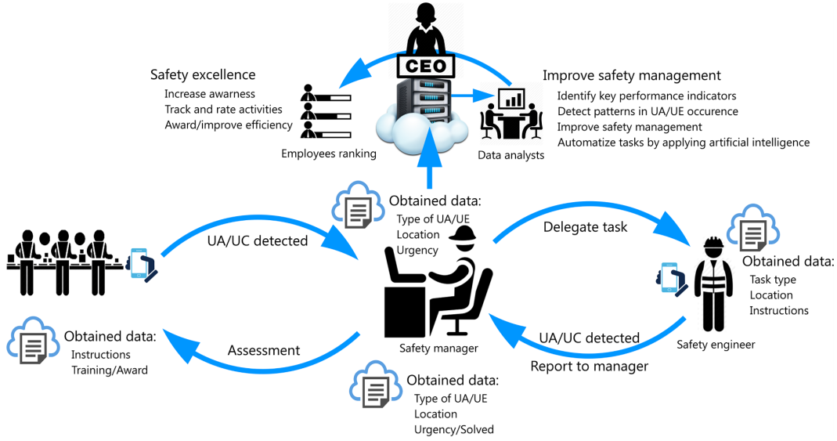
Figure 1 – The generic workflow of an arbitrary Safety 4.0 reporting solution as defined in Vukicevic et al. 2019 [11]
The identification of NU and NP represents the beginning of the process. Registration of UC and UA is allowed to all users (employees, safety managers). Reporting implies defining UC and UA, i.e. their: types, locations and levels of risk. After sending the report to the system, the responsible person receives the notification and should create a work task based on the collected information. The task may be to: a) send instructions to employees at the scene (i.e. steps of their further actions or clarifications if they have misunderstood the reported UC/UA); and b) send instructions to the maintenance engineer/manager to solve the problem. Upon completion of the work, the engineer sends feedback to the system, which notifies the OSH manager/engineer of the current status of the task. If the task is successfully completed, the OSH manager/engineer closes the task; otherwise, he continues the correspondence and gives additional instructions until the successful solution of the reported problem.

Composing parts of an arbitrary report
Each report should provide clear answers to four key questions that identify each UC and UA: “Localization?”, “Classification?”, “Prioritize?” and “Describe?” (Figure 2).
Localization of UC/UA is performed by intuitive graphical user interface (GUI). This implies precise localization, which could be done by selecting predefined items in the menu list (i.e. with named sectors of THE manufacturing hall).
The UC and UA classification involves selecting predefined options (UC/UA) from the corresponding menu. The list may vary depending on the type of SME (size, type of industry, national regulations, etc.).
The priority of UC and UA defines the urgency to take appropriate action. This information represents the subjective-initial assessment of the safety risKs made by the employee who noticed it in the workspace.
The description of UC and UA allows employees to provide objective information on the detected security risk. The description may contain a text and/or picture message created using a mobile device.
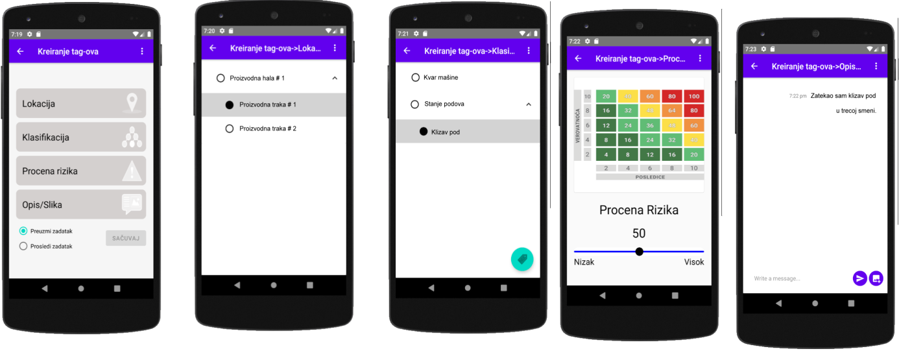
Figure 2– User interface and functionalities for reporting UC and UA. The user should indicate the location, type, description and priority of the UC/UA.

Real time communication and management
In addition to the UC and UA reporting, the framework has a messaging module that allows real-time communication between employees. Delegation of tasks and further correspondence are performed in the form of a company – i.e. correspondence system, where OSH engineers create and decide when a ticket should be closed. Correspondence begins after the UC/UA report is inserter into the database and after the OSH manager/engineer receives the notification of that report. The notification includes the collected data (location, type, description and priority), which the manager reviews and on the basis of which he selects the employee or maintenance engineer to whom he wants to assign a task or send a message. The task consists of details – descriptions of NU/NP, together with the initial message of the manager, as well as all further messages that are exchanged during the process of solving the problem – task. Finally, each user has an insight into the history of their activities, while the manager sees all the active issues and the progress made in performing the tasks.
Due to the size of the company (20 ~ 30 employees) and the structure, the OSH management team consists of employees and managers. UML diagrams of the use of a customized solution are given in Vukicevic et al., 2019, while its corresponding menus are shown in Figure 3. Users access the system by logging in or requesting registration. Both types of users have the following functionalities: 1) Reporting on UC/UA (functionality “Creating tags” in Figure 3); 2) Responding to assigned tasks (“Solve the task” in Figure 3) and 3) Getting to know your reporting history and performance (“Results” feature in Figure 3).
The “Assigned Tasks” functionality lists all the tasks assigned to the logged-in user. So, you need to select a task from the list (i.e. “Tag 25“ in Figure 3) to be solved, which further leads to the correspondence window (in Figure 3). User correspondence window is implemented as Live chat, in which employees exchange text or picture messages in real time (similar to social networks). After the manager estimates that the task has been completed, he marks the correspondence as “Resolved”.
The user-manager has additional functionality that allows him to assign work tasks to employees (including himself) in connection with the collected UC/UA (“Open tags” function in Figure 3). Once the tag (report) is saved in the central database, the user-manager is notified of how many “Open Tags” are left.
The user-manager can also review the running work tasks and tags (UC/UA), check the provided information (in Figure 3). The assigned work task (in Figure 3) also involves selecting responsible employees from the drop-down menu and providing instructions on their further actions.
User interaction depends on how one logs into the system. If the logging is performed as a worker, the activities of collecting-creating tags and executing-solving work tasks are available to the person. If the user is logged in as a manager, he is also allowed to assign work tasks to other users. The diagram shows that the system enables competitive-parallel execution of all three activities (regardless of which user performs them). Each of the three listed activities has its “sub-activities”, which are omitted from the diagram for clarity, i.e. because they are sequential and previously described in the figures where the activity diagram is explained. There are four types of entities in the designed system: Users, Tasks, UC/UA-Tags and Reports (Figure 3).
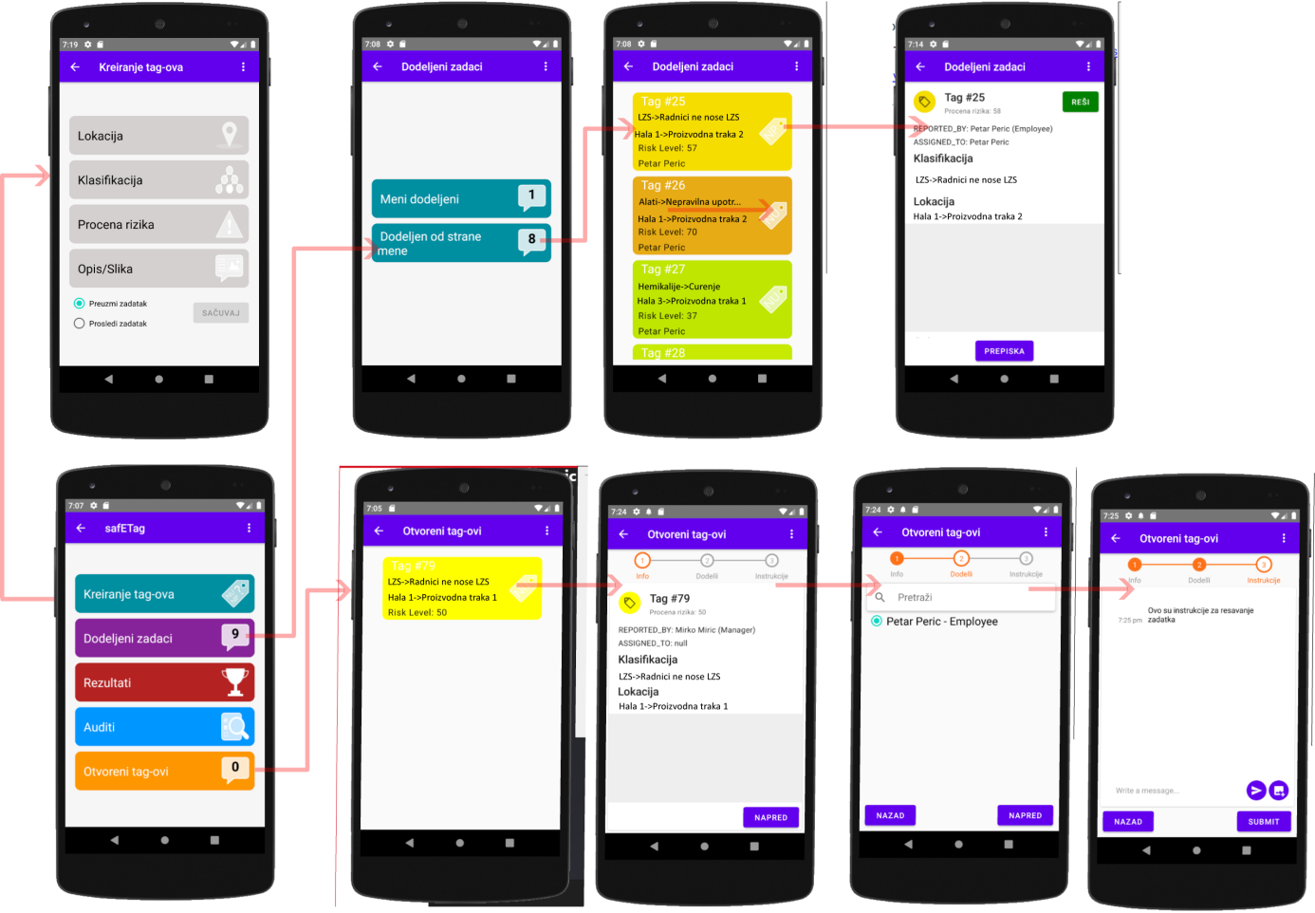
Figure 3 – “Mock-up” of the user interface for report management (image taken from the work of Vukicevic et al., 2019).
An entity relationship diagram (ER diagram) is given in Figure 4. There are four types of entities in the designed system: Users, Tasks, NU/NP – Tags and Correspondence. The relationship between the entities is described in the following diagram:
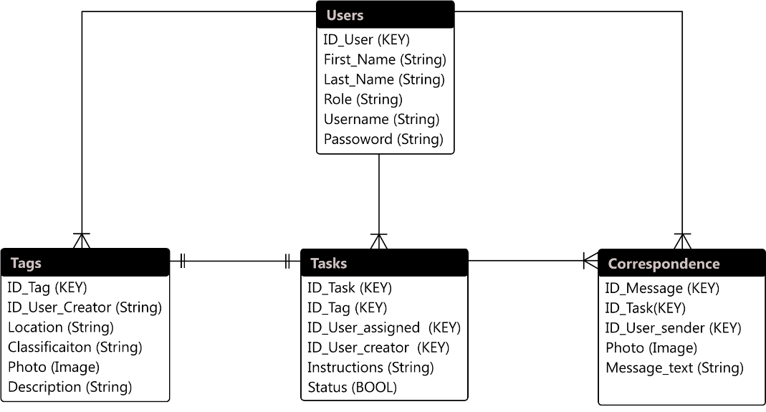
Figure 4 – Activity diagram

Discussion
The main benefits of implementing this proposed framework from a management point of view include the reduction of costs and the complexity of development, adaptation and maintenance. Namely, small and medium enterprises, due to limited financial resources, cannot invest in complex and expensive equipment. Therefore, in the future, the proposed solution, and similar solutions, will have application in SMEs as they do not require the investment of large financial resources. The proposed solution is based on the application of well-documented and open-source technologies, which significantly reduces the complexity and expertise costs. A minimally functional application can be developed by a small experienced programming team. This is because React Native allows users to develop an application and compile it for multiple platforms (iOS, Android). Moreover, React GUI components written for mobile applications can be reused e.g. development of the company web application – and vice versa (the existing web application can be customized to work on the phone). The main problem with the use of smart devices in OSH management is cybersecurity as it is considered that the use of private smartphones in the workplace can create risk [12]. Accordingly, the authors recommend that: a) several smart devices be placed in appropriate places in the workspace, so that employees can approach and use them; or b) include additional software protection so that employees can use applications only if they are logged into the workplace.

Conclusion
Reducing the number of injuries and unplanned and unwanted events at work to zero is an important goal of modern industrial systems. It is accepted that this goal can only be achieved by proactively identifying the precursors of accidents at work such as unsafe conditions and unsafe acts. Unfortunately, the traditional approaches (manual completion and monitoring of UC and UA) applied in almost all small and medium-sized enterprises have shown serious limitations. Although there are a number of commercial solutions in the field of safety and health at work, their application in SMEs is very limited due to a number of factors. The complexity, adaptability and cost of such solutions are the main obstacles to their wider use in SMEs (especially in Serbia), due to limited financial resources compared to corporations and larger companies. On the other hand, most of the solutions presented in the scientific literature are not publicly available, so their application remains negligible in industrial practice. Compared to the current practice, the proposed framework provides benefits to both employees and the employer through: 1) identification of key safety performance indicators; 2) digitization and improvement of existing security reporting systems; 3) improving the OSH culture; 4) better understanding and measuring the contribution of workers in improving safety at work.

REFERENCES
- Hollnagel, E. (2014). Safety-I and Safety-II: The Past and Future of Safety Management. CRC Press.
- Baldissone G., Comberti L., Bosca S. and Murè S. (2018).The analysis and management of unsafe acts and unsafe conditions, Data collection and analysis. Safety Science, 119, 240-251. doi: 10.1016/j.ssci.2018.10.006.
- Heinrich. H.W. (1931). Industrial accident prevention : a scientific approach. New York : McGraw-Hill.
- Hughes, P. (2009). Introduction to Health and Safety at Work. Elsevier.
- Manuele F.A. (2002). Heinrich revisited : truisms or myths. National Safety Council Press.
- Pilloni V. (2018).How Data Will Transform Industrial Processes: Crowdsensing, Crowdsourcing and Big Data as Pillars of Industry 4.0. Future Internet, 10 (3), 24. doi: 10.3390/fi10030024.
- Bauk S., Schmeink A., Colomer J. (2018).An RFID model for improving workers’ safety at the seaport in transitional environment. Transport, 33(2), 353-363. doi: 10.3846/16484142.2016.1233512.
- Golabchi A., Han S., Seo J., Han S., Lee S., Al-Hussein M. (2015).An automated biomechanical simulation approach to ergonomic job analysis for workplace design. Journal of Construction Engineering and Management, 141(8). doi: 10.1061/(ASCE)CO.1943-7862.0000998.
- Wu F., Wu T., Yuce M. (2019).An Internet-of-Things (IoT) Network System for Connected Safety and Health Monitoring Applications. Sensors, 19 (1), 1-21. doi: 10.3390/s19010021.
- Legga S. J., Olsena K. B., Lairda I. S., Hasleb P. (2015).Managing Safety in Small and Medium Enterprises, Safety Science. 71 (Part C), 189-196. doi: 10.1016/j.ssci.2014.11.007.
- Vukicevic A.M., DjapanM., StefanovicM., MacuzicI. (2019).SafE-Tag mobile: A novel javascript framework for real-time management of unsafe conditions and unsafe acts in SMEs. Safety Science, 120, 507-516.doi:10.1016/j.ssci.2019.07.024.

Faculty of Engineering, University of Kragujevac, Sestre Janjic 6, 3400 Kragujevac, Serbia, email: arso_kg@yahoo.com
Faculty of Engineering, University of Kragujevac, Sestre Janjic 6, 3400 Kragujevac, Serbia, email: djapan@kg.ac.rs
Faculty of Engineering, University of Kragujevac, Sestre Janjic 6, 3400 Kragujevac, Serbia, email: miladin@kg.ac.rs
Faculty of Engineering, University of Kragujevac, Sestre Janjic 6, 3400 Kragujevac, Serbia, email: ivanm@kg.ac.rs
Faculty of Engineering, University of Kragujevac, Sestre Janjic 6, 3400 Kragujevac, Serbia, email: marijasavkovickg@gmail.com

