Impact of Distributed ENERGY Resources on
DistributioNnETWORK
Nataša PetrovićBožo IlićBranislav Santrač

Abstract: The paper explain how the distributed energy resources (DER) will impact the relay protection and the current fault in the distribution system (DS). The issues covered include protective device coordination problems due to infeed and bidirectional current flow; effects on synchronizing and autoreclosing. The types of interface transformer connections are compared. Their influence on the protection of the system is based on the type of connections. Changes to relay protection in response to the problems encountered and other solutions that have been applied are also covered. The protection of the generators and the interface protection are specifically omitted from this report. Some issues related to the control of voltage levels and capacitors witching are included. A conventional distribution system is radial in nature, characterized by a single source feeding a network of downstream feeders. Therefore, the voltages decrease towards the end of the feeder from the source, The incidence of distributed generators (DG) in the distribution networks alter the radial nature of distribution, and causes the power flow in reverse direction.
Key words: distributed energy resources, relay protection, current fault

INTRODUCTION
Energy systems are changing rapidly as well as climate conditions, a growing number of connected renewable energy sources and the development of information and communication technology (ICT), and enable a new structure of the power system in which the end consumers are active players, with decisions affecting the operation and further development of the power system. This process enables the installation of distributed energy resources (DER) and microgrid, and the formation of energy communities in which consumers contribute and co-operate to ensure their energy procurement on site. [1] With the development of power systems, distributed generation (DG) has also got rapid development which has become an important form of electrical energy. Traditional distribution systems are mostly single power structure and radial form. With the DG interconnecting, the distribution network is no longer a single-supply network, and a lot of power and load coexist. This will certainly affect the sensitivity and selectivity of the relay protection.
The decision regarding determining the optimal level of DERs connection to the distribution network highlights the following aspects:
- terms of costs
- terms of benefits resulting
- establishing an optimum
- unitary definition of the optimum by all interested parts
- benefits usually attributed to secondary issues such as the reduction of technical loses
- technical loses (the real benefit obtained from the penetration of distributed generation, is a balanced load, an optimal powers flow phases, and the possibility to generate the power in the same node is consumed) [2].
Installation of DRs will not change the topology of the system, but the biggest impact of this will be on the protection of distribution systems. Present protection schemes are simple in which fuses are used for protection of laterals and the fuses are backed by reclosers on the main feeder or the breaker at the substation. In the future such simple schemes will not work as easily as before with high penetration of connected DRs [3].

Protection and relay schemes
A relay is an automatic device that senses an abnormal condition of electrical circuit and closes its contacts. These contacts in turns close and complete the circuit breaker trip coil circuit hence make the circuit breaker tripped for disconnecting the faulty portion of the electrical circuit from the rest of the healthy circuit. Traditional protective relays are intended to quickly identify a fault and isolate it so the balance of the system continue to run under normal conditions. The selection and applications of protective relays and their associated schemes will help achieve reliability, security, speed and proper coordination. The function of protective relaying is to cause the prompt removal from service of an element of a power system when it suffers a short circuit or when it starts to operate in any abnormal manner that might cause damage or otherwise interfere with the effective operation of the rest of the system.
Basic components of relay protection are shown in Figure 1.

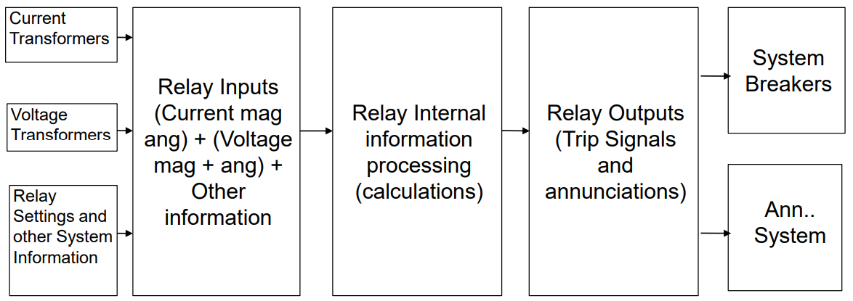
Figure 1 – Basic components of relay protection [5]

Protection zones
A protection zone is a defined protected area which are protected and as such surrounds every piece of power equipment. When a fault occurs in any zone, then only the circuit breaker in that zone trips. Therefore, only a faulty element is disconnected without affecting the rest of the system. [5]
The following six categories of protection zones are possible in a system, (we apply here a concept of selective coordination):
- Generators and generator–transformer units
- Transformers
- Buses
- Lines (transmission, sub-transmission, and distribution)
- Utilization equipment (motors, static loads, or other)
- Capacitor or reactor banks (when separately protected).

Protection devices and components
Protection devices for electrical circuits accomplish two main functions, consistency as well as protection. Protection is assured by detaching power supply in a circuit through overcurrent protection, which removes fire hazards and electrocution.

Fuse
Fuse is the self-destructing device that is used to protect the circuit from overcurrent. Fuses are essential electrical devices, and there are different types of fuses available in the market today based on specific voltage and current ratings, application, response time, and breaking capacity.

Instrument Transformer
Instrument transformers work as a transducer in electrical systems and the accurate protection cannot be achieved without properly measuring the normal and abnormal conditions of a system. Voltage transformers and current transformers measure voltage and current and give feedback on whether a system work normally or not. The current transformer firstly steps down the current to such levels that it can be easily handled by the relay current coil. Secondly, it isolates the relay circuitry from the high voltage of the high voltage system [6], [7].

Circuit Breaker
A circuit breaker is one kind of electrical switch used to guard an electrical circuit against short circuit otherwise an overload which will cause by excess current supply. The basic function of a circuit breaker is to stop the flow of current once a fault has occurred. Not like a fuse, a circuit breaker can be operated either automatically or manually to restart regular operation [7].

Batteries
The other component which is crucial in a protective system is batteries that are used to ensure uninterrupted power to relays and breaker coils. The operation of relays and breakers require power sources, which shall not be affected by faults [6].

ADVANCED PROTECTION SYSTEM
Advanced protection system is shown in Figure 2.
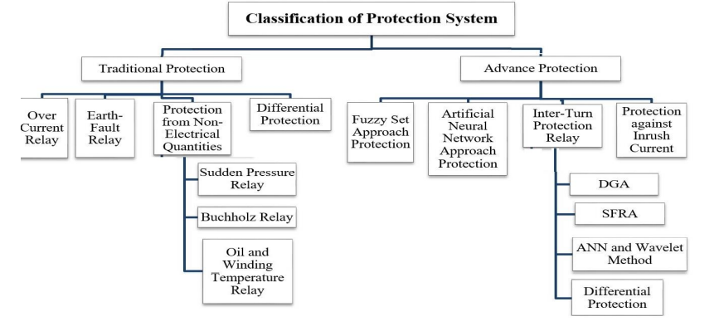
Figure 2 – Advanced protection system. [8]

To get continuous supply of electricity power the system network has to be monitored continuously, which can be achieved by placing relays in the power system network. The relay is hard to design in such a way that it will never fail and because of that there should be a backup protection.
The in service time of the relays in standard time inverse relay model can be calculated by using Eq 1, [9].
$T_{op}^{i}={TDS}_{i}*\left[\frac{α}{{(\frac{I_{fault}}{{I }_{pickup}})}^{β}-1}\right]$ (expression number is lined) (1)
where:
$T_{op}^{i}$ – Total in service time of all relays,
${TDS}_{i}$- Time dial setting,
$\frac{I_{fault}}{{I }_{pickup}}$ – Plug setting multiplier,
$I_{fault}$ – Fault current level,
${I }_{pickup}$ – Pick up value of the relay current above which the relay should operate,
$α,β$ – constants depending on the relay characteristics.
The TDS used in Eq. (1) adjusts the time delay before the relay operates whenever the fault current reaches a value equal to, or greater than, the relay nominal current value.

Impact of penetration level
The penetration level of distributed generation (DG) on the distribution network is measured against the total load demand or the percentage of DG power referred to the rated power of the network. DER units are affected by the voltage quality in the same way as all other equipment. The impact of voltage disturbances includes a reduction of the lifetime of equipment, erroneous tripping of the equipment and damage to equipment. This issue should be addressed in the same way as for large industrial installations: a sharing of responsibility has to be agreed between the operator of the DER unit and the operator of the grid. An important difference between DER units and other equipment connected to the grid is that the erroneous tripping of DER units may pose a safety risk: the energy flow is interrupted potentially leading to machine overspeed and large overvoltages with electronic equipment [10].
Injections of DER endanger the existing protection coordination schemes for the distribution system. The impact depends upon number, size, type and location of DER in the distribution system. Since the location of DER in the distribution system varies, the configuration of distribution systems also changes. The protection schemes that are designed for unidirectional flow of fault currents fail to provide the adequate protection coordination when DER power is injected in the distribution systems. Moreover, there is a requirement of additional number of direction over current relays. The new settings of over current relays depend upon the location of the new incoming DER in the distribution systems [11].

Effects of Distributed Generation on the DS

Harmonic – Harmonics are regarded as one of the main challenges in a DS and big problem with harmonics may happen when different distributed generators (DGs) work together to solve the load sharing problems due to mismatched feeder impedances. Even though load sharing can be achieved, the DS have problems of voltage unbalance and total harmonic distortion (THD) issues at the output of DG terminals as well as at the point of common coupling (PCC) [12].
Voltage regulation – Since there are more DR units added to the DS, the capacity accumulates up to a significant part of the total fee of the collection. The coordination of DR with the regulators of the DS are extremely important in the radial distribution system main regulator. In the substations, the on-load transition transformer method is used with additional line controllers in distribution and switched [13].
Short circuit level – Penetration of DG in a network has a direct impact on the short circuit levels of the network; it causes an increase in the fault currents when compared to the normal network conditions during which the substation is the only generating unit. This increase will be obtained even if the DG is of a small generating capacity. Thecontribution of DG to faults depends on some factors such as the generating capacity of the DG (size of the DG), the distance of the DG from the fault location and the type of DG. Since more than one small DG is embedded in the system, the sum of the current contribution of these DGs to fault could have a significant effect on the protection devices and may cause mis-coordination in the protection scheme and there will be no co-ordination between protective devices resulting in a failure of the protection scheme [13].
Power quality – refers to a wide variety of electromagnetic phenomena that characterize the voltage and current at a given location in the power system. The power quality study in general deals with harmonic injections, voltage fluctuations,voltage sag/swell, flicker, impact of low frequency anti-islanding signal injections and many other phenomena that accompany the integration of the DG in a distribution system [14].

CONSLUSION
At low penetration levels, the effects of DER may not present a risk to DS; however, as penetrations increase, the effect of these resources can present certain reliability challenges that require attention. This leads to areas where further consideration is needed to better understand the impacts and how those effects can be included in planning and operations of the DS. For reliability modeling purposes the data on installed and projected DER units is needed. Important data for modelling include information on the location, type, size, configuration, interconnection characteristics, disturbance response characteristics, and date of operation of the equipment. DER generation profiles would also improve the fidelity of modelling results rather than forcing models to assume worst-case scenarios. It is particularly important that both data and models be available down to the elements of interest to the models like separating the DER generation from the load.

REFERENCES

[1] Alexander Wing Lake Yee “The Impact of Distributed Energy Resources (DERs) in Integrated Gas-Electricity Energy Systems“ , September 2017
[2] Dumitru Federenciuc, Dorel Stănescu, “Impact of distributed generation on distribution networks“, June 2015
[3] Ron Beazer,Ken Behrendt, “Impact of Distributed Resources on Distribution Relay Protection“, August 2004.
[4] Rasheek Rifaat, “Power System Protective Relays:Principles & Practices“, available at :https://site.ieee.org/sas-pesias/files/2016/12/PowerSystemProtectiveRelays_PrinciplesAndPractices.pdf
[5] https://www.allumiax.com/blog/protection-schemes-for-electrical-power-system
[6] Protection Schemes for Electrical Power System
[7] https://www.elprocus.com/what-is-a-protection-device-different-types-of-protection-devices/
[8] Atul Jaysing Patil, Arush Singh,“Traditional and Advanced Protection Schemes of Power Transformer“, April 2019
[9] M.V.Tejeswini, Dr. I Jacob Raglend, “An advanced protection coordination technique for solar in-feed distribution systems“, June 2019
[10] Math H.J. Bollen, Mats Häger, “Interactions between distributed energy resources,
the grid, and other customers“
[11] Manohar Singh, “ Protection coordination in distribution systems with and without distributed energy resources“, July 2017
[12] Hafiz Mudassir M., Rami Ghannam, “Control of Distributed Generators and DirectHarmonic Voltage Controlled Active Power Filters for Accurate Current Sharing and Power Quality Improvement in Islanded Microgrids“, April 2019
[13] Mohamed Talal, “ The Effect of Distributed Generation on Power System Protection“, September 2010
[14] Ali Hariri, “ Impacts of Distributed Generation on Power Quality“, September 2014

Msr, Higher Education Technical School of Professional Studies in Novi Sad, petrovic.n@vtsns.edu.rs ²Dr, Higher Education Technical School of Professional Studies in Novi Sad, ilic@vtsns.edu.rs ³Dr, Higher Education Technical School of Professional Studies in Novi Sad, santrac@vtsns.edu.rs

