A value based network approach for customer engagement improvement
Đorđe ĆelićZoran DraškovićZorica Uzelac Viktorija Petrov

Abstract: Following a survey of the literature relevant to the subject, this study describes a new framework for modeling value based network of customer-organization-society interactions. The value based network approach provides a deeper and more complete understanding of the nature of customer-organization relationships, and influencing factors of the dynamics of these processes. Better understanding of customer engagement may be developed and fostered among differing customer segments. A case example has been provided where this concept is applied. In the presented case study we analyzed engagement of the students as customers of the education services provided by the Faculty of Technical sciences, University of Novi Sad, Serbia. We propose a set of building block elements that shape the education process as a value based network, and define the most influencing factors to student engagement.
Key words: knowledge economy, knowledge management, value based network, customer relations, intellectual capital

introduction
In today’s competitive business environment, which has undergone enormous changes in recent years, knowledge management (KM) is increasingly recognized as a significant factor in gaining a competitive advantage, and one of the major driving forces of organizational change and value creation since the early 1990. While industries continue to upgrade from intensive data processing operations to knowledge-based businesses, the need to understand knowledge management will grow [1], [2]. Knowledge, considered as a strategic resource, requires that managers develop company’s competitive advantage [3].
Knowledge-based firm theory suggests that knowledge is an organizational resource that enables sustainable competitive advantage in a hyper-competitive environment. It is a major driver of value creation and competitive advantage, a generator of critical invisible assets of modern organizations, and intellectual capital of organizations.

Knowledge economy
Changes in the business environment impose changes in the concept, framework and rules according to which companies operate. World economy emerges from an economy that was predominantly based on industrial production and enters the knowledge economy. In the knowledge economy, the driver and the greatest value of the company is located in the competencies of employees, business processes, relationships with customers and suppliers, etc.
The emphasis on knowledge in organizations today is based on the assumption that removing barriers to knowledge transfer and replication has become a strategically important goal. Organizations are forced to compete in the global knowledge and idea economy, where information and knowledge have no boundaries; on the contrary, they multiply and grow at a feverish pace. Rapid development of information and telecommunication technology causes an increase in the share of information and knowledge, both in production technologies and in products, which affects our way of organizing and communicating. This increase in the share of knowledge in the newly created value is the main feature of the transition from the industrial age to the knowledge economy, because information and knowledge are the key factors of business success: know-what, know-how, know-where, know-when.

knowledge managemnt – intellectual capital
At the end of the twentieth century, the difference between the market and book value of a company increased sharply. The most noticeable increase in the value of invisible assets was in the period 1992-2001 when the market value of public companies was on average seven times higher than the book value. This fact explains the growing interest of the scientific and professional public in measuring and managing intellectual capital, and theories are being developed that explain the nature of intellectual capital. In the professional literature, the term intellectual capital is used as a synonym for intangible assets of an organization that significantly affects the success of business, but is not explicitly written in the company’s balance sheet. In recent years, a real expansion of works dealing with the topics of knowledge management in companies and the intangible dimension of the company, its intellectual capital, has been noticed in the management literature [4]. It is believed that the success of a company depends on its ability to create, use and develop its knowledge-based resources [5]-[7].
“Knowledge management is the acquisition and use of resources in order to create an environment in which information is available to individuals and in which individuals collect, share and use information in order to develop their own knowledge. The environment should be such as to encourage and enable the use of knowledge for the benefit of the organization as a whole.”[6]
Although intellectual capital and knowledge management are obviously not the same thing, they are considered to be two very related concepts, two branches of the same tree. Namely:
- Intellectual capital is considered a stock (static dimension), and knowledge management is the flow (dynamic dimension) which increases the value of intellectual capital;
- Knowledge management is a consequence of the fact that intellectual capital exists, ie. the need to manage what the company owns. “Knowledge worker”, or “knowledge organizations” have the role of intellectual processors because the man is the only active agent of knowledge.
Due to these characteristics, it is impossible to separate these two concepts, and they are analyzed together in the academic and professional public. In the contemporary literature dealing with the management of intellectual capital, the concepts of “intellectual capital” and “intangible assets” are considered synonyms and the division of intellectual capital into three families is accepted. According to the authors [8]-[11] the family of human capital (employee competencies), the family of relational or external structure capital (company image, customer relations, as well as other external relations), and the family of organizational or internal structure capital (internal processes and company management). There are a plantiful studies highlighting knowledge management in developed economies and large organizations, but there is lacking of such studies in transitional economies and small organizations. The results published in [12] contribute to reducing the gap that exists in the literature.

value based networks
New business conditions, a new economy, impose the need to expand our view of ‘organization’ through an understanding of the dynamic system of value networks of which it is a part. Intangible and tangible balance sheets can and must be linked into an integrated business picture. It is necessary to develop rigorous analytical methods and concepts that will look at entire networks of relationships that generate economic value through complex dynamic exchanges between individuals, groups, or organizations.
The world around us consists of tangible resources (oil, factories, money, etc.) but also of intangible resources like energy and information. Since in the knowledge economy intangible resources are more valuable than tangible resources, we need to create a new approach as well as methodologies to be able to understand and influence both tangible and intangible resources and processes. The analysis of value networks is precisely this new way of perceiving the position and relationships of the organization with its environment in the new economic reality. The concept of value networks, and the analysis of flows through the value network developed by the organization, will allow us to see a comprehensive exchange of both tangible and intangible values [13], [14].
Verna Allee [12] has developed a value network analysis, a complete mapping system and process analysis in order to understand the creation of tangible and intangible value among participants in the system. The value network analysis provides a standard way to define, map, and analyze participants, transactions, and tangible and intangible variables that together form a value network. The value network analysis can lead to a complete change in the perception of the problems facing the organization, as well as mobilize the joint action of all participants in the value network in order to implement the change [12]. Taking into account the participation of all actors in the exchange, the clear contours of the organization from the industrial economy are lost. The organization in the knowledge economy is integrated with its environment and extends to both the “user’s user” and the “supplier’s supplier”.
In order to develop a strategy based on the value network it is necessary to map out the value exchange accros the network. The basic concepts of the value network mapping methodology are [13]:
- Roles are played by participants in the network who provide contribution and carry out functions. They can be individuals, teams, business units, wholе organizations, communities, or governement.
- Transactions or activities originate with one participant and end with another. Transactions are presented by arrows. Solid line arrows present tangible exchanges such as product and revenue. Dashed lines depict intangible flows. The transaction has its destination – a real person or a participant who accepts it.
- Deliverables are objects of a transaction, and they can be tangible (e.g. a product, a document, report, etc.), or intangible (e.g. knowledge, information, etc.).

customer relationship management
Companies must know how to manage all organizational intangible capital, intellectual capital (IC), and consequently the customer-company relationship, as part of IC. Managing intangible exchanges with costumers is an important part of KM. For an enterprise that already manages its customers as its core business, CRM is its core competency, and, most likely, its competitive advantage.
Companies operating in today’s highly competitive markets face major challenges: how to acquire customers efficiently and to effectively retain them. This problem can be solved with focus on customer engagement, defined as the strengthening of the customer relationship across touch points and transactions.
Some benefits of this engagement can be realized immediately in tangible, bottom-line results. Others are part of a long-term strategy to show customers how company is utilizing its resources to anticipate and meet customer needs.
Creating engagement depends on the ability of the organization to develop customer loyalty, deliver customer service, and anticipate customer needs:
- By focusing on customer engagement, companies gain competitive advantage by delivering the unique customer experiences that drive purchase and cement loyalty.
- By improving customer engagement companies can streamline processes and minimize costs, while delivering the personalized attention and service that customers crave for. Companies that differentiate themselves with unique customer experience gain competitive advantage.
- By discovering and anticipating customer needs and providing the services that they demand, companies can turn a casual customer into a long-term, high-value business partner. Companies can use their knowledge of customer activities to guide strategies for retaining and building multichannel relationship with their most important customers. Companies that learn about their customers’ needs, through torough and engaged communication with them, are in a position to identify new opportunities and tailor product offers to suit customers’preferences. In a competitive market there is no better way to build profitable customer relationship then by educating them about additional products that could streamline their businesses.
When customers are fully engaged, it means the business relationship has a foundation of loyalty and trust. Trust is a prerequisite, the most important factor for the flow in value networks.

case study
The example presented in this paper illustrates the methodology of creating motivational strategies to increase customer engagement in the process of exchange with the organization. The model is based on key factors; value network, participants, and flows of tangible and intangible transactions through the network.
The proposed methodology was applied to a case study that looks at students as users of educational service, and the Faculty as an organization that provides the service. The research was conducted with the aim of determining the possibilities of development and application of the value network model at institutions of higher education, on the example of the Faculty of Technical Sciences, Department of Industrial Engineering and Management, University of Novi Sad, Serbia. The basic value that is placed in the focus of the research is the exchange of knowledge, and motivation for the engagement of students in the process of acquiring and exchanging knowledge. The research aims to illustrate the proposed methodology by focusing on students and their interactions with other elements of the value network of the educational process, such as: teaching staff (professors, assistants, etc.), non-teaching staff (student services and other administrative staff), as well as a wider community. The research uses statistical methods in order to prove or reject defined hypotheses, such as the hypothesis that it is possible to identify key current motivational factors that affect student engagement in the educational process.
The core aim of the case study is the development of a reliable model of a value based network and key motivating factors that affect the efficiency and effectiveness of the education process. The process of creating the model can be divided into phases: 1) Working with a focus group with the goal of creating an instrument for determining the motivational factors that affect the degree of student engagement in the educational process; 2) Conducting survey within a selected sample; 3) Analysis of survey results and definition of key factors that affect the engagement of students in the educational process; 4) Defining key participants, transactions, transaction objects (tangible and intangible) and creating the value network.
The goal of the first phase of the research was to define motivators and de-motivators, current and potential, in talks with the focus group of students, which were used to create a questionnaire for the second phase of the research. The focus group was selected in a way that it represented study groups within which students learned, cooperated, and shared knowledge and experiences. Respondents in the focus group were asked to list what motivated, demotivated, or could have potentially motivated and demotivated them to learn and share knowledge with others. A total of 119 different items were defined to which the respondents had to give answers, that is, to express their position. In order to measure the attitudes of the respondents, an instrument was created that consisted of three parts. The first part contained instructions for completing the questionnaire. The second part had an explanation for the scale according to which respondents were to express their views on each of the elements of the questionnaire. The third part of the questionnaire consisted of 119 variables in relation to which the respondents were supposed to express their opinion. The items were divided into four parts: current de-motivators, potential de-motivators, current motivators and potential motivators. In order to measure attitudes, a five-point Likert scale was used.
The research was conducted on the group of the 5th year students at the Faculty of Technical Sciences, Department of Industrial Engineering and Management who attended lectures on the subject of Knowledge Management. 57 respondents participated in the research.
In order to analyze the results of the research, the following statistical techniques were used: Descriptive statistics; Hierarchical cluster analysis – Ward's linkage; Exploratory factor analysis. These analyses were performed on the entire sample, and then on the three observed clusters. Cluster analysis determined the segmentation of the sample and, therefore, we decided to analyze the value networks for each segment separately, all with the aim of the effectiveness of strategies that should result from the analysis of value networks.
In the whole sample and in clusters individually, the variables were ranked according to the significance level, and the level of agreement among respondents. The KMO (Kaiser-Mayer-Olkin) test and the Bartlett test were used to analyze the justification of the application of factor analysis. No specific number of factors was requested. All the communalities of the items were greater than 0.3. All factors that accounted for 75% of the variance were considered.

Table 1 – The subset of the key factors
Tangible |  |  | Intangible |  | Students | Teaching staff | Administration | Studt. services |  | Government | Employers | Student org.
 |  |  | Opening of new training opportunities after graduation
 |  |  | Becoming independent
Student exchange
 |  |  | Active participation in the creation of study programs
More scholarships for advanced students
Contemporary learning methods
Opportunity to access contemporary literature
 |  |  | Better attitude of society towards knowledge
 |  |  | Transparent employment criteria
 |  |  | Continued economic crisis due to transition
 |  |  | Expensive books
 | Curent motivators |  | Potential motivators |  | Potential  de-motivators

By selecting variables in factors that had high saturation and were in the first third of the ranking of variables by the level of importance and level of agreement among respondents, a subset of key factors that have the highest influence on student engagement in the education process was identified, Table 1.
By identifying the walue network roles, i.e. participants in the transactions for each of the identified key factors, the value network was desined, Figure 1.

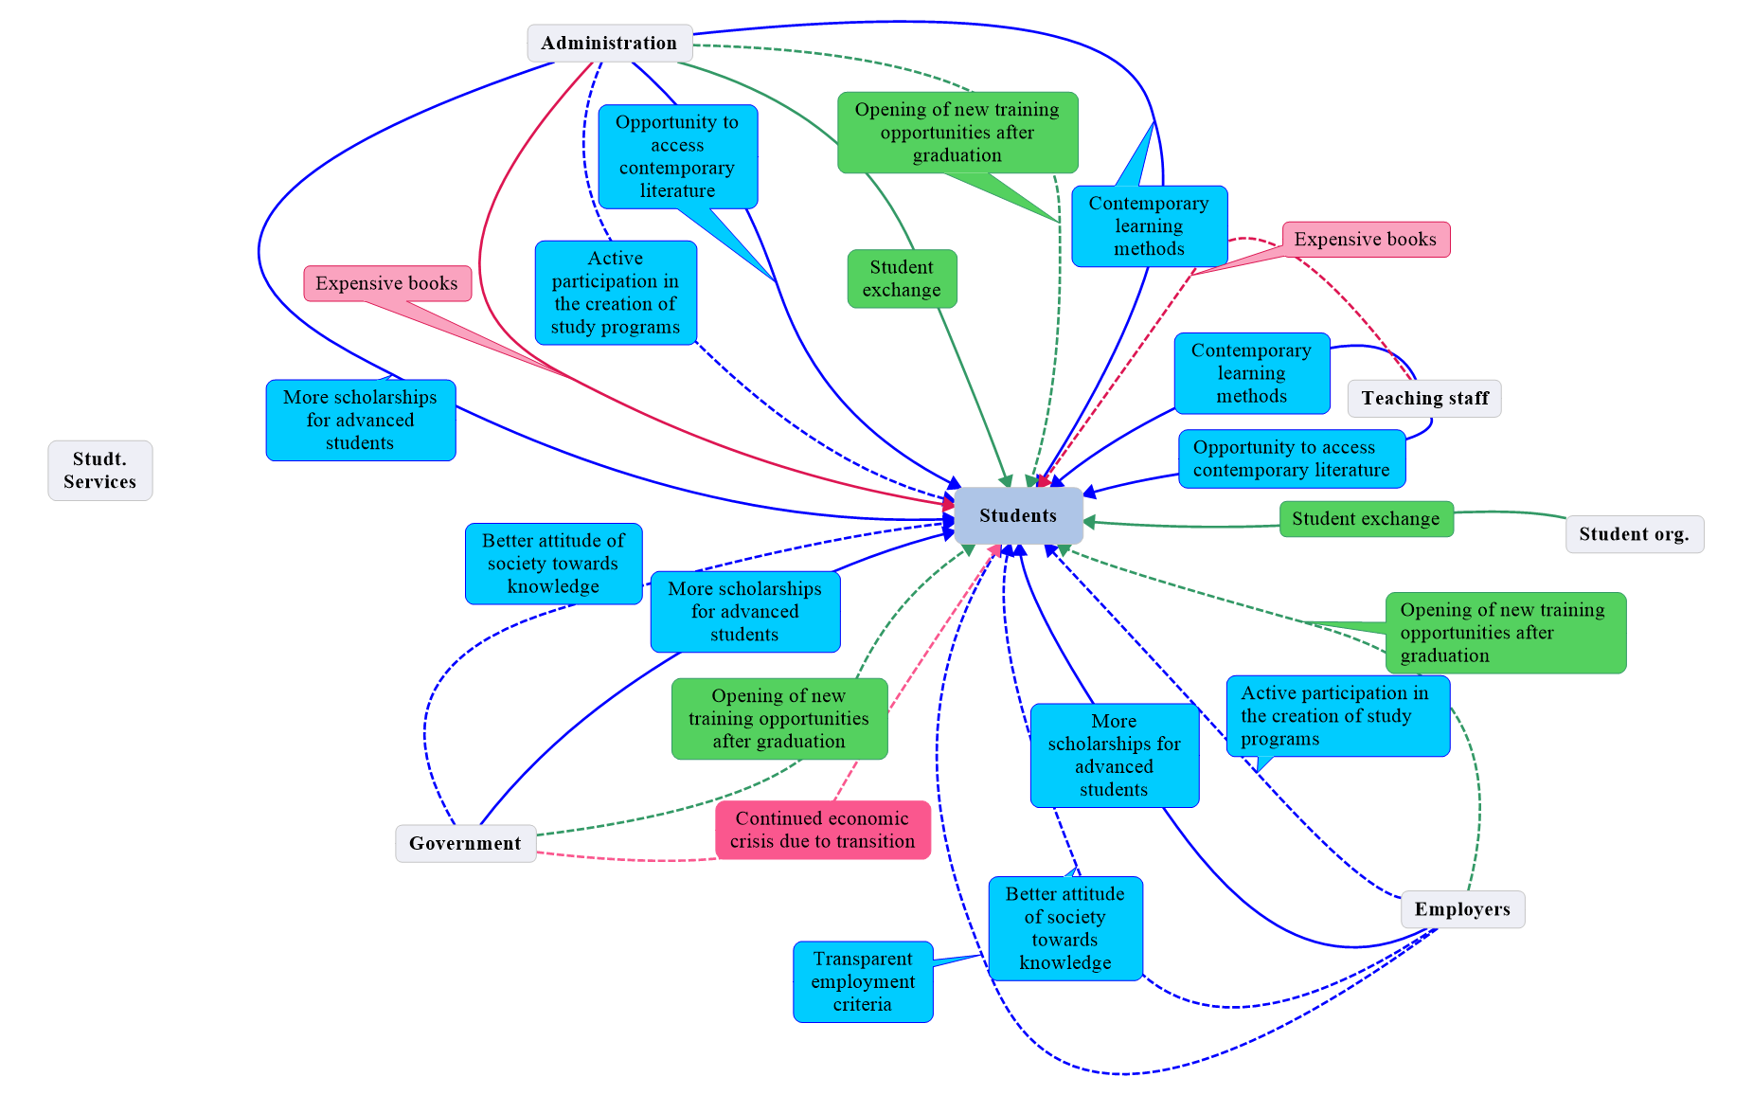
Figure 1 – The value network

conclusions
Group of 57 (student) respondents participated in this research. As the aim of the research was to determine the possibility of applying the given methodology to higher education institutions, and research itself was of the experimental type, the sample size was considered appropriate. In the further course of research, the created value network should be analyzed by asking three basic questions related to [13]: exchange analysis, impact analysis and value creation analysis. The analysis of the value network is about assesing the value dynamics and conversion capability of the system as a whole.

REFERENCES
- Mangabeira Unger, R. (2020). The Knowledge Economy :A Critique of a Dominant View. American Affairs, 4(3). Retrived from https://americanaffairsjournal.org/2020/08/the-knowledge-economy-a-critique-of-the-dominant-view/
- Mangabeira Unger, R. (2019). The Knowledge Economy. London: Verso. ISBN: 9781788735001
- Newell, S., Robertson, M., Scarbrough, H., and Swan, J. (2009). Managing Knowledge Work. Palgrave Macmillan.doi.org/10.1111/j.1467-9310.2011.00656.x
- Von Krog, V.,Grand, S. (2002). From Economic Theory Towards a Knowledge-Based Theory of the Firm:Conceptual Building Blocs.In Choo, C. W., Bontis,N., editors.The Strategic Management of Intellectual Capital and Organizational Knowledge. Oxford University Press. ISBN: 0-19-513866-X
- Sveiby, K. (2001). A knowledge-based theory of the firm to guide in strategy formulation. Journal of Intellectual Capital, 2(4), 344–358. ISSN 1469-1930
- Herman, C., Brelade, S. (2000). Knowledge Management and the Role of HR. Financial Times&Prentice Hall, ID: 167009387
- Grant, RM. (2002) The Knowledge-Based View of the Firm. In: Choo CW, Bontis N, editors. The Strategic Management of Intellectual Capital and Organizational Knowledge. Oxford University Press. ISBN: 0-19-513866-X
- Andriensen, D. (2004). Making Sence of Intellectual Capital: Designing a Method for the Valuation of Intangibles. Burlington: Elsevier Butterworth-Heinemann. ISBN: 978-0750677745
- Roos, G., Bainbridge, A., Jacobsen, K. (2001) Intellectual capital as a strategic tool.Strategy and Leadership Journal, 29(4), 21-28. http://dx.doi.org/10.1108/10878570110400116
- Sharma, S., Dharni, K. (2020). Measurement and reporting of intangible assets: orientation of Indian practitioners. Decision , 47, 125–135. https://doi.org/10.1007/s40622-020-00240-y
- Meritum Project. (2002). Guidelines for Managing and Reporting on Intangibles. Intellectual Capital Report, Fundación Airtel Móvil, Madrid, 2002.ID: 17073232
- Petrov, V., Ćelić, Đ., Uzelac, Z., Drašković, Z. (2020) . Three pillars of knowledge management in SMEs: evidence from Serbia. Int. Entrep ManagJ, 16, 417–438. https://doi.org/10.1007/s11365-018-00557-2
- Verna Allee, (2008) “Value network analysis and value conversion of tangible and intangible assets”, Journal of Intellectual Capital, Vol. 9 Issue: 1,pp. 5-24, doi: 10.1108/14691930810845777
- Antonaras, A., Dekoulou, P.E. (2016). Enterprising Culture: Innovation and Value-Network. In Entrepreneurial Challenges in the 21st Century: Creating Stakeholder Value Co-Creation (pp. 94-106). Palgrave Macmillan. https://doi.org/10.1057/9781137479761_6

Assistant professor, University of Novi Sad, Faculty of Technical Sciences, Trg Dositeja Obradovića 6, Novi Sad, celic@uns.ac.rs:
Lecturer, University of Novi Sad,Faculty of Technical Sciences,Trg Dositeja Obradovića 6, Novi Sad, zoran.draskovic@uns.ac.rs:
Professor, University of Novi Sad, Faculty of Technical Sciences,Trg Dositeja Obradovića 6,Novi Sad,zora@uns.ac.rs:
Assistant professor, University of Novi Sad, Faculty of Economics, Sentandrejski put 9-11, Subotica,viktorija.petrov@ef.uns.ac.rs:

